*Florida International University*

*School of Computing and Information Sciences*

CIS 4911 - Senior Capstone Project

Software Engineering Focus

Feature Document

User Story # 548

**Team Member:**

Garrett Lemieux

**Product Owner(s)**:

Francisco Ortega

**Mentor(s)**:

Francisco Ortega

**Instructor**: Masoud Sadjadi

# 

# **User Story**

* As a User I would like to draw lines using the leap motion device so I can paint the surface.

## **Use Case**

Paint lines using leap motion

* Details:
* Actor:
  + User
* Pre-conditions:
  + Leap Motion device is enabled.
  + User can paint lines on canvas.
  + User has correctly started program.
* Description:
  + Use case begins when User has decided to paint a line on screen.
  + User can interact with leap motion and green circle will appear on screen to signal user is near painting canvas.
  + User can paint on canvas by moving finger towards screen.
* Post-conditions:
  + The area that Users interacts with on canvas will have lines drawn to canvas.
* Decision Support:
  + Frequency: High , User will need to interact with canvas to create pictures
  + Criticality: High , Allows Users to draw with hands by using leap motion
  + Risk: High, Had to learn new technology
* Constraints:
* Usability:
  + Need to be able to read user guide and follow instructions
* Reliability
  + Reliable
* Performance
  + Performance High , low failure
* Supportability
  + Leap Motion Device
* Modification History:
  + Owner: Garrett Lemieux
  + Initiation Date 02/07/2015
  + Date last Modified: 02/014/2015

## **Sequence Diagram**

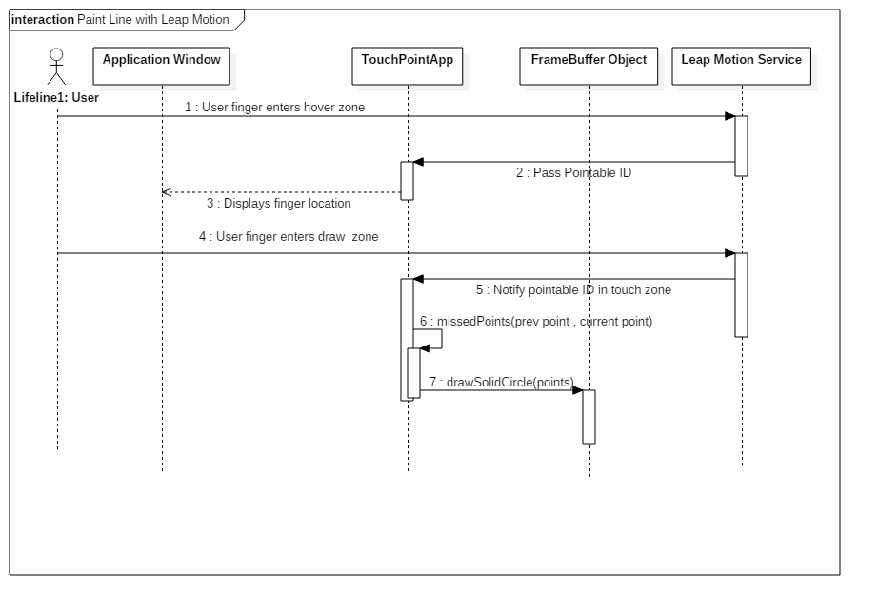

## 

## **Class Diagram**

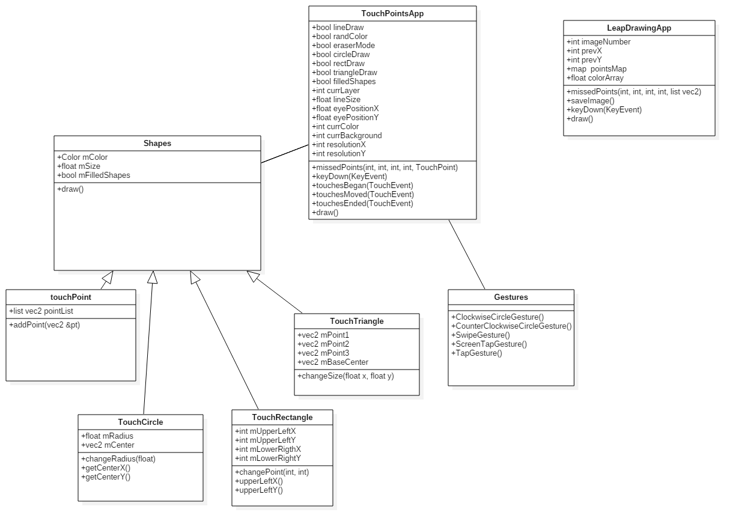

## 

## **Unit Test**

* A user can draw smooth lines using fingers. Both hands may paint and up to ten fingers can be used at once.

## **Integration Test**

* The ability to draw lines using leap motion is compatible with the touchPoints app.

## **User Guide**

* User must place hands over leap motion and extend fingers outward. Once user would like to draw he or she moves hands towards canvas with fingers extended. As the hand approaches the drawing campus the fingers will appear as a green circle. Green circles represents the user is hovering over the drawing canvas. By moving even closer to the canvas the circles will disappear the user will be actively drawing lines.